PHYSICAL DEMANDS ANALYSIS
FIRM NAME: |  | DATE:
JOB TITLE: | Fuel Truck | HOURS OF WORK:
TIME OF DAY WHEN CONCERN HAPPENS: |  | MAIN CONCERN:

Essential – A task that must be completed by the worker in order for the job objective to be fulfilled
Non-Essential – A task is not performed on a regular basis OR the objective can still be completed if the task is removed.
PHYSICAL DEMANDS ANALYSIS -FORCE
 | Check if | Usual Weight (lb) |  |  |  | Frequency |  |  |  |  | DISCUSSION
DEMANDS | Performed | 1-20 | 20-50 | >50 | MAX | N | S | 0 | F | C | (Essential or Non-Essential)
Lifting/Lowering  (floor to work area) |  |  | X |  |  |  | X |  |  |  | - Maintenance
Lifting/Lowering  (above shoulder) |  |  | X |  |  |  | X |  |  |  | - Maintenance
Carrying |  |  |  | X |  |  |  |  | X |  | - Hose
Pushing  (waist or shoulder level) |  | X |  |  |  |  |  | X |  |  | - Shifting gears
Pulling  (waist or shoulder level) |  |  |  | X |  |  |  |  | X |  | - Shoulder and waist level for maintenance work  - Shifting gears (if applicable)  - Pulling out hose
Possible Recommendations:
□ Add Another Lifter □ Reduce Load Lift □ Raise Load off Floor □ Lower Load to Shoulders □ Redesigned Package □ Chutes and Hoppers
□ Add handles □ Use Scissor Lift □ Use Power Lift □ Change Layout □ Use Tilted Surface □ Smaller Lot Size
□ Use Mechanical Aid □ Automate Job □ Training □ Use Lazy Susan □ Adjustable Stands

PHYSICAL DEMANDS ANALYSIS –WORK ENVIRONMENT
 | Check if | Frequency |  |  |  |  | DISCUSSION
DEMANDS | Performed | N | S | 0 | F | C | (Essential or Non-Essential)
Congested Worksite or Locations |  |  |  |  |  | X | - Truck area
Conditions of Working or  Walking Surfaces (level?  clear?) |  |  | X |  |  |  | - Logging debris
Location of Work |  |  |  | X |  |  | - Whole body vibration (depending on road conditions)
Condition of Stairs/Ramps |  |  |  |  |  | X | - Hot and Cold environments depending on seasons  - Heat in truck for winter and A/C in truck for summer
 |  |  | X |  |  |  | - Filling gas (if applicable)
Possible Recommendations:
□ Dampen Vibration □ Better Maintenance □ Eliminate Task □ Training □ Video Tape Analysis □ Motion Analysis Study
□ Work Load Balance □ Task lighting □ Job Rotation □ Exercise Break

PHYSICAL DEMANDS ANALYSIS -MOBILITY

 | Check if | Frequency |  |  |  |  | DISCUSSION
DEMANDS | Performed | N | S | 0 | F | C | (Essential or Non-Essential)
Sitting |  |  |  |  | X
Standing |  |  |  |  | X |  | - Circle checks  - Fueling up
Walking |  |  |  |  | X |  | - Circle checks  - Fueling up
Twisting |  |  | X
Bending (at waist) |  |  | X |  |  |  | - Maintenance and circle checks
Crouching (bend knees) |  |  | X |  |  |  | - Maintenance and circle checks
Climbing  (indicate ladder or stairs) |  |  |  | X |  |  | - Ladder (to top of tank area)
Balancing |  |  | X
Crawling |  |  | X
Awkward Positions |  |  | X |  |  |  | - Maintenance and circle checks
Possible Recommendations:
□ Add Foot Rest □ Use Anti-Fatigue Mats □ Use Cushioned Insoles □ Better Stool/Chair □ Sit-Stand Stool □ Reduce Surface Size
□ Tilted Work Surface □ Adjustable Chair

PHYSICAL DEMANDS ANALYSIS -DEXTERITY

 |  | Check if | Frequency |  |  |  |  | DISCUSSION
DEMANDS |  | Performed | N | S | 0 | F | C | (Essential or Non-Essential)
Reaching  Level |  |  |  |  |  |  | X | - Shifting gears
Above or Below Shoulder |  |  |  |  |  | X |  | - Performing maintenance  - Fueling
To the side |  |  |  | X |  |  |  | - Performing maintenance and circle checks
Fingering  (i.e. typing) | 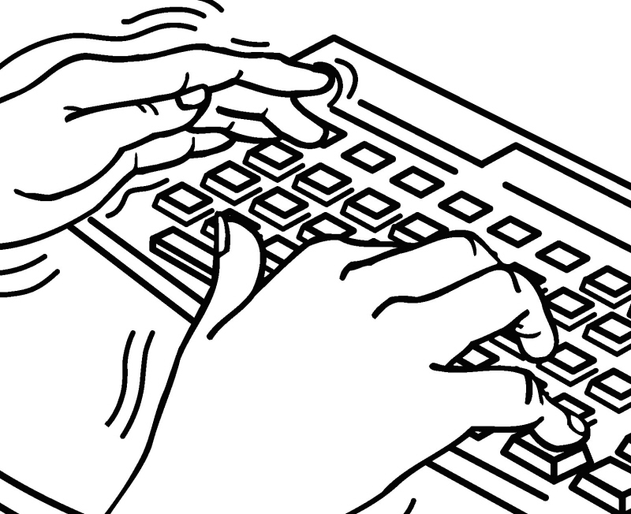 |  |  | X
Handling |  |  |  |  | X
Gripping  Pinch | 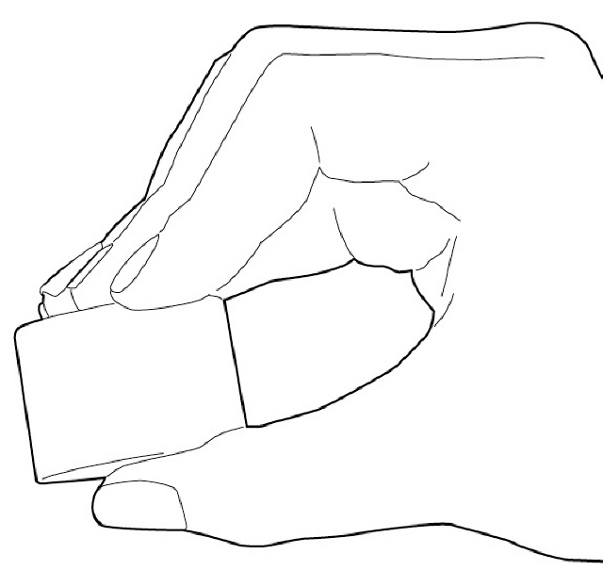 |  |  | X |  |  |  | - Performing maintenance  - Shifting gears (if applicable)
Hook | 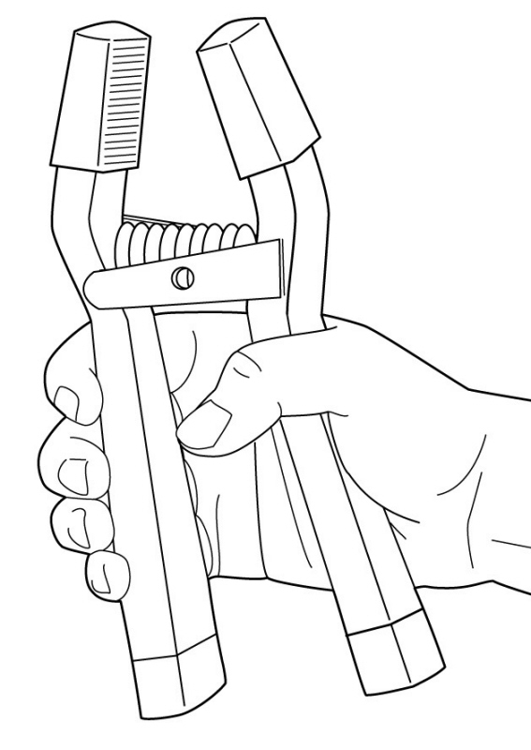 |  |  |  |  |  | X | - Performing maintenance  - Controls in truck  - Fueling
Screw or Turn |  |  |  |  |  | X |  | - Performing maintenance
Cut |  |  |  | X |  |  |  | - Performing maintenance
Eye/Hand Coordination |  |  |  |  |  |  | X
Eye/Hand/Foot Coordination |  |  |  |  |  |  | X
Possible Recommendations:
□ Use Power Grip □ Improve Heights □ Adjustable Work Height □ Reduced Weight □ Align Work Heights □ Use Lighter Tool
□ Redesign Job □ Supply Smaller Tools □ Supply Larger Tools □ Modify Tool Handle □ Use Torque Bar □ Supply Gloves

PHYSICAL DEMANDS ANALYSIS - POSTURE/JOINT POSITION REQUIRED
 |  | Check if | Frequency |  |  |  |  | DISCUSSION
DEMANDS |  | Present | N | S | 0 | F | C | (Essential or Non-Essential)
Neck Position  Flexion  (bend downward) | 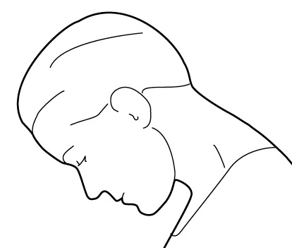 |  |  |  |  |  | X | - During circle checks  - When driving
Extension  (bend upward) | 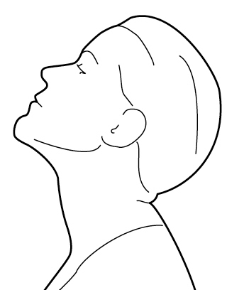 |  |  |  | X |  |  | - During circle checks  - When driving
Rotation  (looking to the side) | 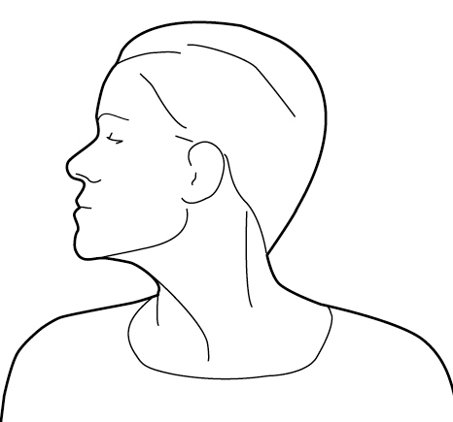 |  |  |  |  | X |  | - During circle checks  - When driving
Shoulder Joint  Flexion  (arm brought in front) | 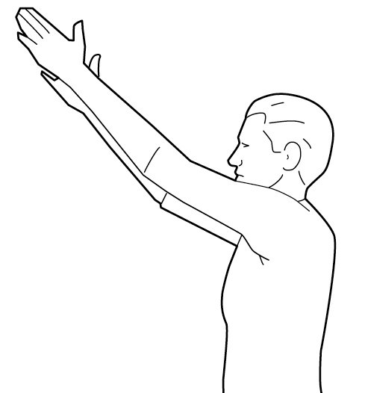 |  |  |  |  |  | X | - Performing maintenance and circle checks  - Changing gears (if applicable)
Extension  (arm brought behind) | 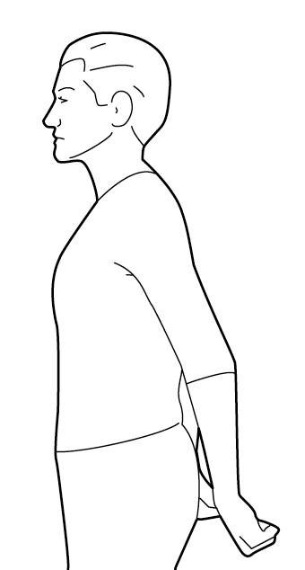 |  |  |  |  |  | X | - Performing maintenance and circle checks  - Changing gears (if applicable)
Abduction  (arm brought out to the side) | 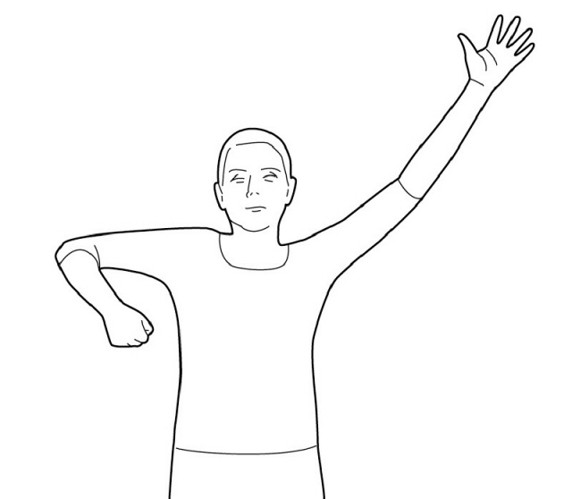 |  |  | X |  |  |  | - Performing maintenance and circle checks  - Fueling
Wrist  Flexion  (bend forward) | 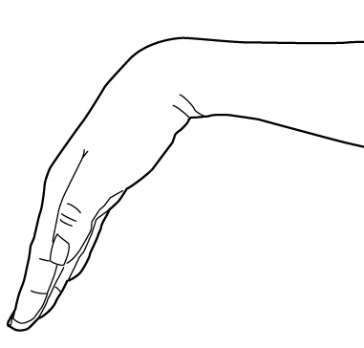 |  |  |  |  |  | X | - When performing maintenance and circle checks  - Right sided for gear shift (if applicable)  - Opening valves
Extension  (bend backward) | 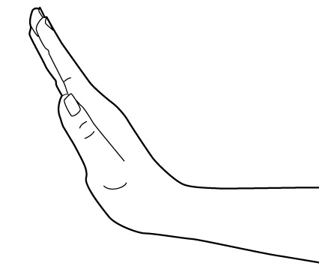 |  |  | X |  |  |  | - Performing maintenance and circle checks
Ulnar Deviation  (to the little finger side) | 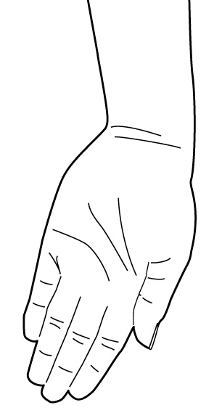 |  |  | X |  |  |  | - Performing maintenance and circle checks  - Opening valves
Radial Deviation  (to the thumb side) | 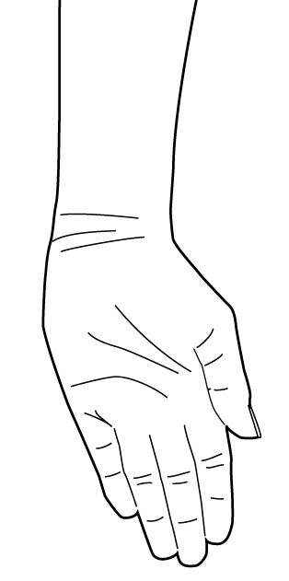 |  |  | X |  |  |  | - Performing maintenance and circle checks  - Opening valves
Pronation  (palm down) | 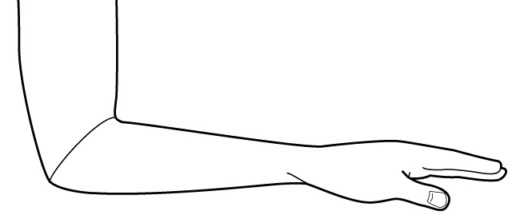 |  |  |  |  |  | X | - Using gear shift and steering wheel  - Performing maintenance and circle checks  - Opening valves
Supination  (palm up) | 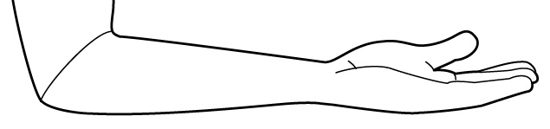 |  |  | X |  |  |  | - Performing maintenance
Back  Flexion  (bend forward) | 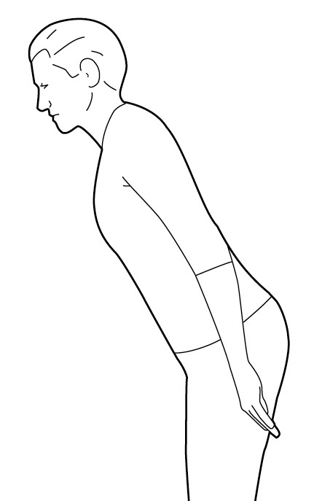 |  |  | X |  |  |  | - Performing maintenance
Extension  (bend backward) |  |  |  | X
Rotation  (twisting to side) | 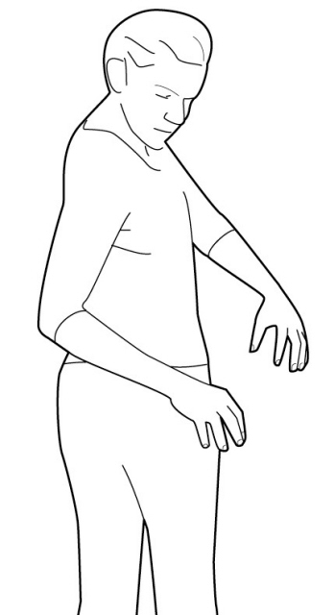 |  |  | X |  |  |  | - Performing maintenance
Lateral Bend  (bending to the side) | 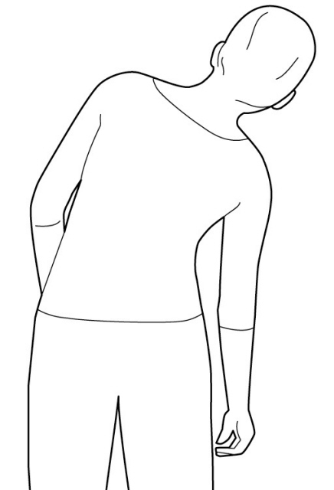 |  |  | X
Straight |  |  |  |  |  |  | X | - Sitting
Possible Recommendations:
□ Power tool □ Different Tool □ Improved Tool □ Layout changes □ Work Methods □ Counter Balanced Tool
□ Angled Tool Grip □ Titled Work Surface □ Grip Wrap □ Automated Job □ Fixture for Product □ Counter Balanced Arm
□ Better Gloves □ Mechanical Assisted □ Fixture for Tool □ Bend Tool Handles □ Arm Supports

CONTROLS IN PLACE: | - This job requires different tasks to be done at different times, for example there may be a period where no maintenance is required and other times where a great deal is required  - Road conditions will effect some of the demands
WORKER RECOMMENDATIONS:
SUPERVISOR/
MANAGEMENT
RECOMMENDATIONS:
Possible Recommendations:
□ Dampen Vibration □ Better Maintenance □ Eliminate Task □ Training □ Video Tape Analysis
□ Motion Analysis Study □ Work Load Balance □ Task Lighting □ Job Rotation □ Exercise Breaks
□ Reduce Workload □ More Frequent, Shorter Rest Breaks

