PHYSICAL DEMANDS ANALYSIS
FIRM NAME: |  | DATE:
JOB TITLE: |  | HOURS OF WORK:
TIME OF DAY WHEN CONCERN HAPPENS: |  | MAIN CONCERN:

Essential – A task that must be completed by the worker in order for the job objective to be fulfilled
Non-Essential – A task is not performed on a regular basis OR the objective can still be completed if the task is removed.
PHYSICAL DEMANDS ANALYSIS -FORCE
 | Check if | Usual Weight (lb) |  |  |  | Frequency |  |  |  |  | DISCUSSION
DEMANDS | Performed | 1-20 | 20-50 | >50 | MAX | N | S | 0 | F | C | (Essential or Non-Essential)
Lifting/Lowering
(floor to work area)
Lifting/Lowering
(above shoulder)
Carrying
Pushing
(waist or shoulder level)
Pulling
(waist or shoulder level)
Possible Recommendations:
□ Add Another Lifter □ Reduce Load Lift □ Raise Load off Floor □ Lower Load to Shoulders □ Redesigned Package □ Chutes and Hoppers
□ Add handles □ Use Scissor Lift □ Use Power Lift □ Change Layout □ Use Tilted Surface □ Smaller Lot Size
□ Use Mechanical Aid □ Automate Job □ Training □ Use Lazy Susan □ Adjustable Stands

PHYSICAL DEMANDS ANALYSIS –WORK ENVIRONMENT
 | Check if | Frequency |  |  |  |  | DISCUSSION
DEMANDS | Performed | N | S | 0 | F | C | (Essential or Non-Essential)
Congested Worksite or Locations |  |  |  |  |  |  | -
Conditions of Working or  Walking Surfaces (level?  clear?) |  |  |  |  |  |  | -
Location of Work |  |  |  |  |  |  | -
Condition of Stairs/Ramps |  |  |  |  |  |  | -
 |  |  |  |  |  |  | -
Possible Recommendations:
□ Dampen Vibration □ Better Maintenance □ Eliminate Task □ Training □ Video Tape Analysis □ Motion Analysis Study
□ Work Load Balance □ Task lighting □ Job Rotation □ Exercise Break

PHYSICAL DEMANDS ANALYSIS -MOBILITY

 | Check if | Frequency |  |  |  |  | DISCUSSION
DEMANDS | Performed | N | S | 0 | F | C | (Essential or Non-Essential)
Sitting
Standing
Walking
Twisting
Bending (at waist) |  |  |  |  |  |  | -
Crouching (bend knees)
Climbing  (indicate ladder or stairs) |  |  |  |  |  |  | -
Balancing
Crawling
Awkward Positions |  |  |  |  |  |  | -
Possible Recommendations:
□ Add Foot Rest □ Use Anti-Fatigue Mats □ Use Cushioned Insoles □ Better Stool/Chair □ Sit-Stand Stool □ Reduce Surface Size
□ Tilted Work Surface □ Adjustable Chair

PHYSICAL DEMANDS ANALYSIS -DEXTERITY

 |  | Check if | Frequency |  |  |  |  | DISCUSSION
DEMANDS |  | Performed | N | S | 0 | F | C | (Essential or Non-Essential)
Reaching  Level |  |  |  |  |  |  |  | -
Above or Below Shoulder |  |  |  |  |  |  |  | -
To the side
Fingering  (i.e. typing) |  |  |  |  |  |  |  | -
Handling
Gripping  Pinch |  |  |  |  |  |  |  | -
Hook |  |  |  |  |  |  |  | -
Screw or Turn |  |  |  |  |  |  |  | -
Cut
Eye/Hand Coordination
Eye/Hand/Foot Coordination
Possible Recommendations:
□ Use Power Grip □ Improve Heights □ Adjustable Work Height □ Reduced Weight □ Align Work Heights □ Use Lighter Tool
□ Redesign Job □ Supply Smaller Tools □ Supply Larger Tools □ Modify Tool Handle □ Use Torque Bar □ Supply Gloves

PHYSICAL DEMANDS ANALYSIS - POSTURE/JOINT POSITION REQUIRED
 |  | Check if | Frequency |  |  |  |  | DISCUSSION
DEMANDS |  | Present | N | S | 0 | F | C | (Essential or Non-Essential)
Neck Position  Flexion  (bend downward) | 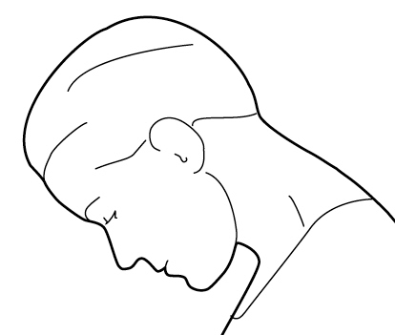
Extension  (bend upward) | 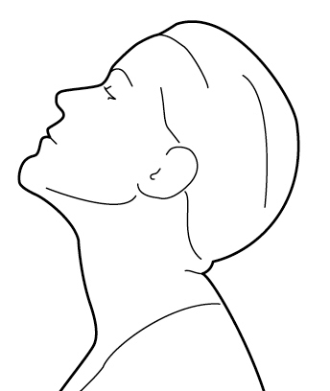 |  |  |  |  |  |  | -
Rotation  (looking to the side) | 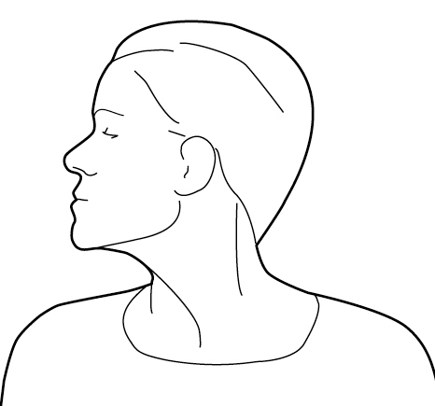 |  |  |  |  |  |  | -
Shoulder Joint  Flexion  (arm brought in front) | 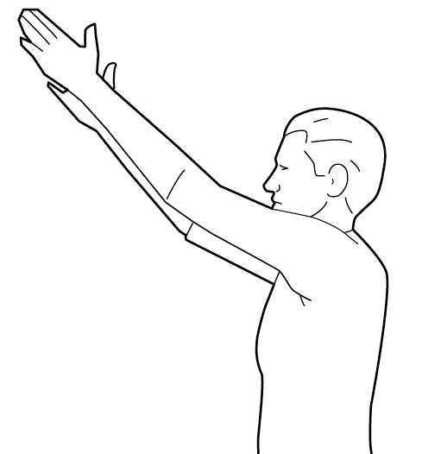
Extension  (arm brought behind) | 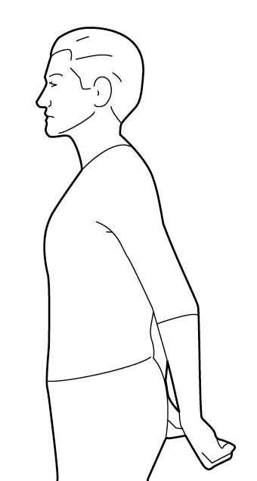 |  |  |  |  |  |  | -
Abduction  (arm brought out to the side) | 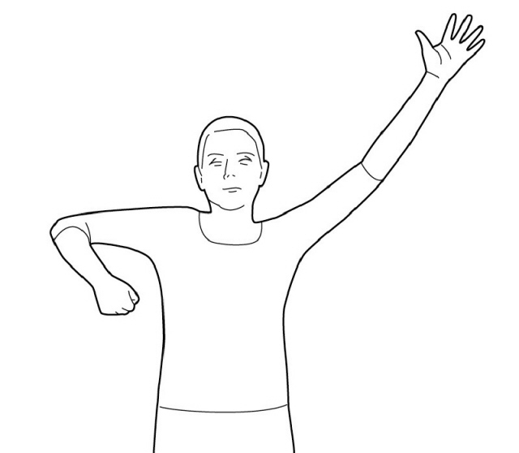
Wrist  Flexion  (bend forward) | 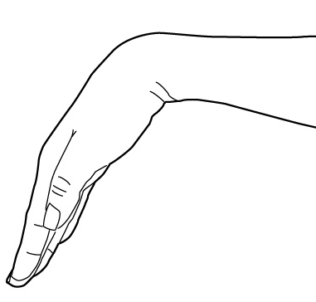 |  |  |  |  |  |  | -
Extension  (bend backward) | 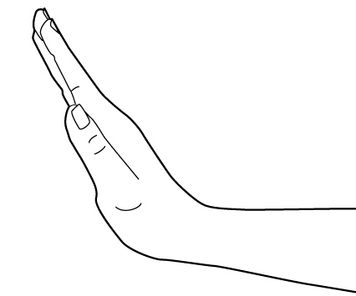
Ulnar Deviation  (to the little finger side) | 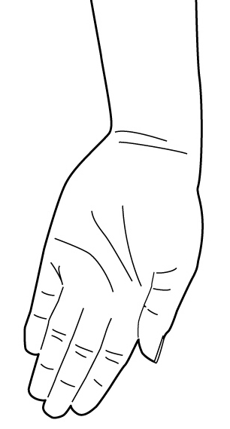 |  |  |  |  |  |  | -
Radial Deviation  (to the thumb side) | 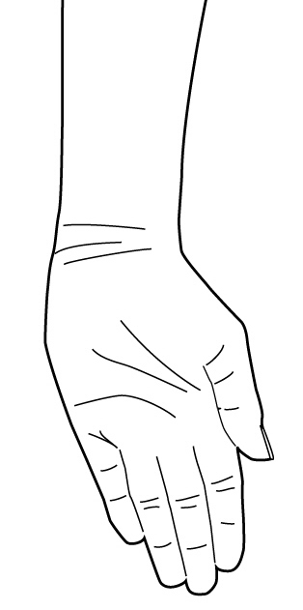
Pronation  (palm down) | 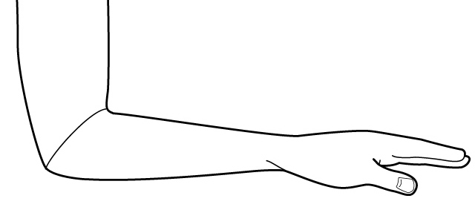
Supination  (palm up) | 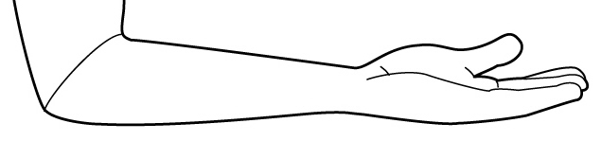
Back  Flexion  (bend forward) | 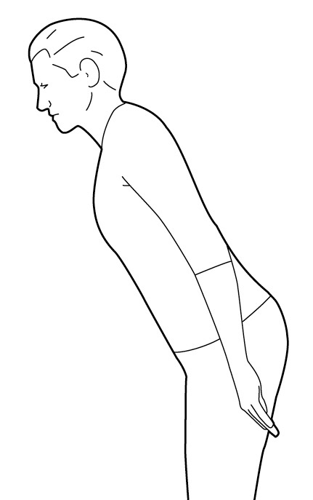
Extension
(bend backward)
Rotation  (twisting to side) | 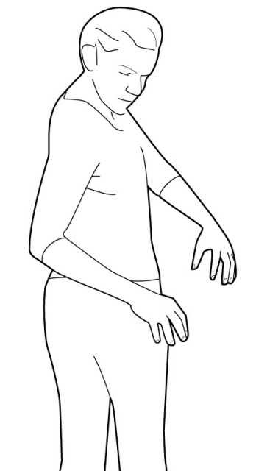
Lateral Bend  (bending to the side) | 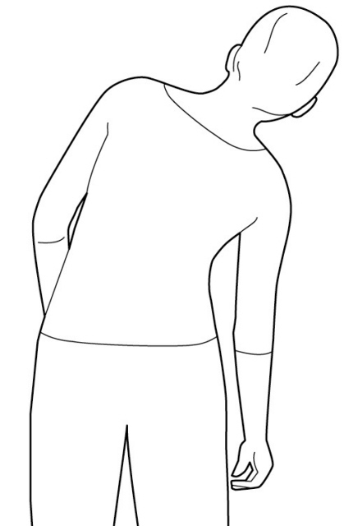
Straight
Possible Recommendations:
□ Power tool □ Different Tool □ Improved Tool □ Layout changes □ Work Methods □ Counter Balanced Tool
□ Angled Tool Grip □ Titled Work Surface □ Grip Wrap □ Automated Job □ Fixture for Product □ Counter Balanced Arm
□ Better Gloves □ Mechanical Assisted □ Fixture for Tool □ Bend Tool Handles □ Arm Supports

CONTROLS IN PLACE: | -
WORKER RECOMMENDATIONS:
SUPERVISOR/
MANAGEMENT
RECOMMENDATIONS:
Possible Recommendations:
□ Dampen Vibration □ Better Maintenance □ Eliminate Task □ Training □ Video Tape Analysis
□ Motion Analysis Study □ Work Load Balance □ Task Lighting □ Job Rotation □ Exercise Breaks
□ Reduce Workload □ More Frequent, Shorter Rest Breaks

