This sample procedure should be customized to fit the needs of your company. Refer to your internal program and determine what you need for your requirements. Once you have done that, simply add or delete from this procedure to integrate it into your internal processes.
This procedure is not meant to be used as-is.
Return-to-work Program Requirements, Forms and Tools

Date of Issue: choose issue date | Review Date: choose date for review
Written by: person(s) who wrote document | Date: insert date written
Reviewed by: person(s) who reviewed | Date: insert date written
Approved by: person responsible for process | Date: insert date written

PURPOSE
A return-to-work (RTW) plan is a written document developed collaboratively by the injured or ill worker, the worker’s supervisor or manager, the treating health professional (through the provision of functional abilities information) and, where appropriate, the RTW Co-ordinator and/or Union Representative. The Return-to-Work (RTW) Plan is developed with a focus on creating a return to work plan, promote consistent administration, helps prevent future injury and promote recovery of the injured/ill person.
SCOPE
This standard applies to all employees, supervisor and owner.
RELATED DOCUMENTATION
Internal
- Document 1: Functional Abilities Form
- Document 2: Return-to Work-Plan
- Document 3: Contact Log
- Document 4: Return to Work Progress Report
- Document 5: Physical and Cognitive Demands Analysis (regular and transitional assignments)
- Document 6: Letter to Health Care Practitioner
- Document 7: Modified work offer letter to injured/ill person
- Document 8: Medical Consent for release of information
- Document 9: Return-to-work plan closure and evaluation feedback forms

External
- Workplace Safety and Insurance Board
- WSIB Workwell Evaluation Templates

DEFINITIONS
Functional Abilities Form | The purpose is to keep track if contact with the workers as well as treating health care professionals and case managers. Your company will decide on the frequency of contact and the method of contact such as telephone follow-up with the worker, one -on-one meetings, emails or letters.
Return to Work Plan
Contract Log | The purpose is to keep track if contact with the workers as well as treating health care professionals and case managers. Your company will decide on the frequency of contact and the method of contact such as telephone follow-up with the worker, one -on-one meetings, emails or letters.
Return to Work Progress Report | The purpose is to monitor and record the worker’s progress while they are accommodated on modified duties. Regular meetings and communication provide both parties with an opportunity to discuss any concerns the worker may be experiencing
Physical and Cognitive Demands Analysis | A Physical Demands Analysis is a systematic procedure to quantify and evaluate all the physical and environmental demand components of all essential and non-essential tasks of a job. A cognitive demand analysis (CDA) is designed to provide an assessment of a workplace and identify the essential job duties and cognitive demands of a job.
Letter to Health Care Practitioner | The purpose of the letter is to inform the treating health care practitioner of the company’s RTW program and its willingness to work together with them and the worker as per the restrictions
Return to Work Closure/ Evaluation Report | The purpose is to evaluate the results by having both worker and the worker’s supervisor or manage complete a Return to work Closure/Evaluate Report. The evaluation report provides employer with information on what worker and the opportunities for improvement
Regulated Health Care Professional | An external treatment provider who is regulated and licensed to practice health care in Ontario.
Medical File | Medical Documentation provided by the employee or the employee’s attending healthcare provider to be kept in control by [Your Company] for the purposes of assessing a request for medical accommodation and/or absence from work, documents medical precaution, and/or return to work planning
Modified work | - Work hardening – increasing a worker’s strength gradually by combining regular and modified job duties;  - Transitional/Modified work – when an injured employee, while active in an ESRTW program, is temporarily performing activities other than their pre-injury activities during the recovery period of their work-related injury;  - Reduced hours – reducing an employee’s hours of work;  - Gradual increase in hours – beginning with reduced hours and increasing the number of hours worked gradually;  - Work adjustment – modify the employee’s regular job to meet restrictions;

ROLES & RESPONSIBILITIES
Senior Management is responsible for:
- Establish, monitor and support the progress of all employees participating in an RTW plan and maintain records of the employee’s progress and up to date restrictions till the end of the plan
- Allocate human and financial resources for the administration of the RTW Program
- Provide training and education to all managers, supervisors and workers regarding the program
- Provide a safe work environment
Manager/Supervisor is responsible for:
- Developing individual RTW written plan as per the restrictions with the injured employee
- In collaboration with your worker and union representative (if applicable) identify and provide modified or alternative work consistent with worker’s functional abilities restriction and address any concerns as they may arise
- Regular follow-up and communication with the injured worker and to monitor and record worker’s progress in the plan
- Provide WSIB with a copy of RTW plan and supervise and maintain the plan
Employees are responsible for:
- Cooperate, follow-up and maintain regular communication during the RTW plan with the Manager/Supervisor and WSIB
- Participate in prescribed treatment and rehabilitation programs
- Assist employer to identify suitable and available work, consistent with functional abilities and where possible, restores pre-injury earnings
- Cooperate, follow-up and maintain regular communication during the RTW plan with the Manager/Supervisor and WSIB
- Comply with medical and rehabilitation treatment and arrange appointments during non-work hours wherever possible
- Maintain regular contact with the supervisor/RTWC during periods of absence and while participating in a RTW plan
- Attend all scheduled RTW meetings
- Contribute to the development of the RTW plan.
- Communicate any concerns to the supervisor/RTWC
- Immediately advise the supervisor /RTWC of changes in circumstances

Health and Safety Coordinator is responsible for:
- Ensure worker, supervisor and other parties involved understand what to except and they all maintain communication between themselves
- Assist in developing of individualized RTW plans and participate in reviewing job demands and compare to the worker’s functional abilities. Identify barriers that prevent a return to work and determine modifications to overcome the hurdles
- Act as mediator to resolve disputes
- Evaluate the program regularly
- Maintain the confidentiality of the worker’s RTW personal file
Union (where applicable)
- Provide visible support for the RTW program
- Assist with the identification of RTW accommodations
- Support the worker during the RTW process
- Ensure worker rights are protected during the RTW process
Workplace Safety and Insurance Board (WSIB) / Insurers
- Adjudicate claims in a timely manner.
- Provide medical, rehabilitation, work reintegration and dispute resolution support to facilitate the return to work process.
RTW/Disability Management committee
- Assist in the development of policies and procedures for the RTW program.
- Monitor the performance of the RTW Program, making recommendations for continuous improvement.
Procedures
Return to Work Planning
- The supervisor and RTWC will arrange a joint meeting with the worker and the union (where applicable) to:
- Confirm the functional abilities to determine whether the worker can return to their regular job
- Identify and discuss the job duties the worker believes they can perform and any barriers regarding the job duties/tasks they feel unable to complete due to their injury/illness
- Obtain input from the workplace parties (worker, union and supervisors) regarding possible accommodations as necessary.

Determine and analyze accommodation options and factors:
- Type of accommodation - temporary or permanent?
- Health and safety – does the accommodation place the worker or co-workers at risk?
- Complexity of the accommodation – will a third-party assessment or installation be required? How long will it take to put in place? Will training for the worker and coworkers be required?
- Suitability – will the accommodation render the work safe, suitable and sustainable? Are the duties productive, consistent with the worker’s functional abilities and does it restore their pre-injury/illness earnings to the greatest extent possible

Resources required
- have all parties been included and budget requirements been considered and approved? Have all sources of funding been considered up to the point of undue hardship and/or are there alternative means including internal resources that can build/install the accommodations if within their abilities (i.e. engineering, maintenance, etc.)?
- Collaborate throughout the meeting(s) to reach agreement on the best option or options based on the outcome of the discussion and analysis of removal of barriers and hazards
- Develop a progressive plan for RTW with input from all parties.

-Note: RTWC will ensure the worker is able to travel safely to the meeting and offer assistance in making travel arrangements if needed while ensuring that the meeting location is accessible as per the worker’s needs as required.
- If the worker requires accommodation(s) a Return to Work Plan will be developed and documented on the Return to Work Plan Form. The plan must be mutually agreed upon and signed by the worker, the supervisor and the RTWC. Where there is disagreement, follow the Dispute Resolution Process.
- If the RTW plan cannot be developed due to the workers functional abilities, the RTWC or supervisor to monitor the recovery and functional abilities until such time as the worker can safely participate in RTW activities.
- If the workplace parties are unable to agree on a RTW plan, or arrange a joint meeting to discuss RTW with the worker, the dispute resolution process outlined below will be followed. • In the event that a meeting to discuss modified work cannot be scheduled with the worker for any reason, a RTW Plan may be developed by the RTWC and the supervisor. The RTWC will send a Modified Work Offer Letter and a copy of the proposed RTW Plan to the worker by registered mail.

For occupational disabilities, the RTWC will advise the WSIB of the offer, and the worker’s response.

The RTW Plan will specify:
- time frames,
- functional abilities/limitations,
- identification and description of suitable tasks in detail,
- accommodations required,
- responsibilities, and
- emergency evacuation requirements (if applicable).

Dispute Resolution Process
In situations where there are concerns or disputes related to the RTW Plan or process, the workplace parties will use the following procedure.
- Disputes may arise from, but are not limited to:
- suitability of assigned tasks, tools or equipment,
- functional and cognitive abilities,
- lack of progression of recovery, and
- safety concerns.
- The resolution of disputes will be addressed in the following manner:
- Worker must notify the Supervisor or the RTWC of the concern or dispute. The worker is encouraged to identify potential solutions. Concerns/disputes will be documented on a Progress Report Form.
- The Supervisor will investigate the concern and discuss possible solutions with the worker. If both parties agree, the solution is implemented and the RTW Plan is updated.
- If the concern is not resolved, the Supervisor must notify the RTWC.
- The RTWC investigates the concern and considers possible solutions with the worker, the Supervisor and the union representative (where applicable).
- If all parties agree, the solution is implemented and the RTW Plan is updated

- The dispute resolution process may require the RTWC to:
- Seek clarification or input from the worker’s health care professional(s)
- Seek clarification or input from the WSIB or STD/LTD Case Manager
- Refer the worker for an independent medical examination (IME)
- Refer the worker for a functional ability evaluation (FAE) or cognitive abilities evaluation.
- Request an ergonomic assessment.
- Request a referral to a WSIB RTW Specialist or Work Transition Specialist to facilitate a resolution (occupational cases only)
- if the worker’s concern or dispute is not resolved, the worker may:
- Pursue an appeal with the WSIB or STD/LTD insurer
- Initiate a grievance (unionized workers only)
- Pursue a complaint with the Ontario Human Rights Commission, WSIB-RTW Specialist, WSIB Appeal, 3rd Party Mediation
Program Evaluation:
- The RTWC will prepare and present an annual RTW Program evaluation report to senior management and the RTW Committee that includes the following information:
- total number of WSIB claims
- total number of WSIB lost time days
- total number of accommodated days for occupational disabilities
- total accommodation costs including benefit costs paid by employer
- the total number of RTW plans resulting in the following outcomes
- regular duties with no accommodation
- regular duties with accommodation
- alternate job with no accommodation
- alternate job with accommodation, or
- leave of absence
- summary of supervisor suggestions for program improvement
- summary of worker suggestions for program improvement
- recommendations for program improvement
- recommendations for budget allocation.

The senior management team, in collaboration with the RTWC and the RTW Committee will establish a budget for the RTW Program, develop objectives for continuous improvement and implement an action plan that includes:
- defined objectives,
- assignment of responsibilities for each objective,
- target dates for completion.

Document 1: Functional Abilities Form
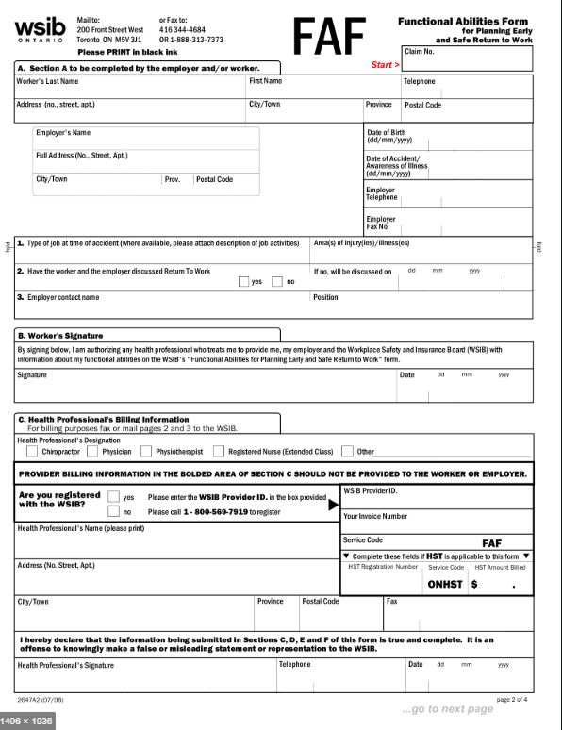
Document 2: Return-to Work-Plan

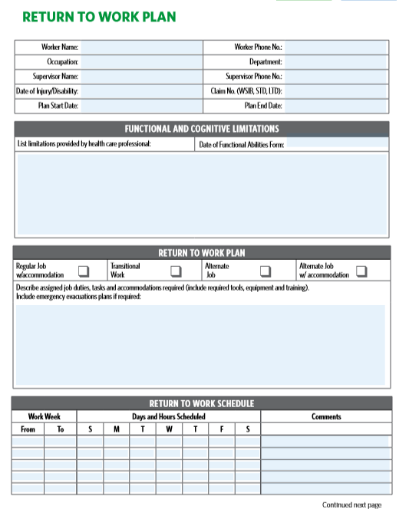
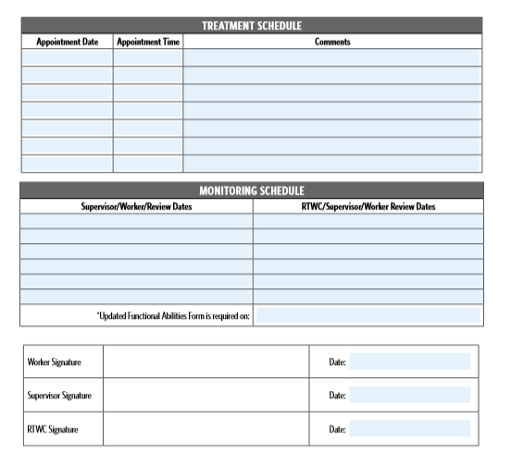
Document 3: Contact Log
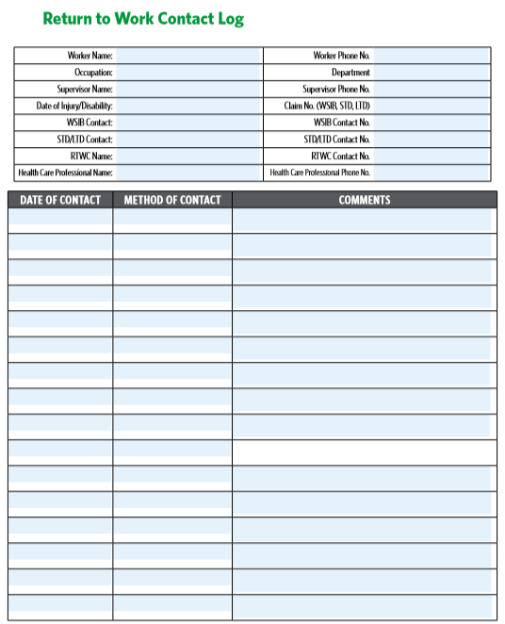
Document 4: Return to Work Progress Report
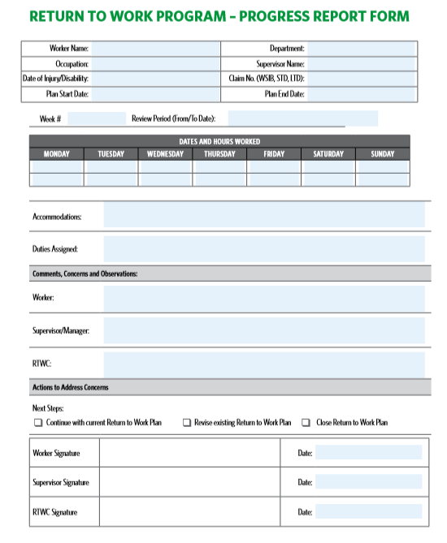
Document 5: Physical and Cognitive Demands Analysis
- Created as per the job positions of the Organization
- Below is an template of PDA

Task Element | 0
Task Photo |  |  |  |  |  | Description and Comments
 |  |  |  | Task Duration
 |  |  |  | Task Frequency | 0
 |  |  |  |  | Enter data
 |  |  |  |  | Choose Option
Physical Demand | Frequency | Weight (kg) | Start Height (cm) | End Height (cm) | Hand(s) Used | Horizontal Reach (cm) | Grip Type | Comments
Lift/Lower
 | Frequency | Weight (kg) | Height (cm) | Distance (m) | Hand(s) Used | Horizontal Reach (cm) | Grip Type | Comments
Carry
 | Frequency | Average Force (kg) | Maximum Force (kg) | Height (cm) | Distance (m) | Hand(s) Used | Grip Type | Comments
Push
 | Frequency | Average Force (kg) | Maximum Force (kg) | Height (cm) | Distance (m) | Hand(s) Used | Grip Type | Comments
Pull
 | Frequency | Height (cm) | Horizontal Reach (cm) | Hand(s) Used |  |  |  | Comments
Reach
 | Frequency | Force (kg) | Height (cm) | Direction | Hand(s) Used | Horizontal Reach (cm) | Grip Type | Comments
Grip
 | Frequency | Force (kg) | Height (cm) | Direction | Hand(s) Used | Horizontal Reach (cm) |  | Comments
Pinch
 | Frequency | Duration (mins) | Height (cm) | Surface | Tool Type |  |  | Comments
Write
 | Frequency | Duration (mins) | Height (cm) | Finger(s) Used | Hand(s) Used | Precision Level |  | Comments
Fine Finger Movement
 | Frequency | Seat Height (cm) | Dimensions | Surface |  |  |  | Comments
Sit
 | Frequency | Surface | Footwear |  |  |  |  | Comments
Stand
 | Frequency | Distance (m) | Surface | Footwear |  |  |  | Comments
Walk
 | Frequency | Duration (mins) | Knee(s) Used | Surface |  |  |  | Comments
Kneel
 | Frequency | Duration (mins) |  |  |  |  |  | Comments
Crouch/Squat
 | Duration (mins) | Leg(s) Used | Surface |  |  |  |  | Comments
Balance
 | Frequency | Duration (mins) | Distance (m) | Surface |  |  |  | Comments
Crawl
 | Frequency | Duration (mins) | Distance (m) | Surface |  |  |  | Comments
Climb
 | Frequency | Food(s) | Precision Level |  |  |  |  | Comments
Taste
 | Frequency | Odor Type (s) | Precision Level |  |  |  |  | Comments
Smell
 | Frequency | Information | Level of Detail |  |  |  |  | Comments
Speech
 | Frequency | Duration (mins) | Sound(s) | Sound Level |  |  |  | Comments
Hear
 | Frequency | Duration (mins) | Sound(s) | Sound Level |  |  |  | Comments
Feel/Tactile
 | Frequency | Information | Level of Detail |  |  |  |  | Comments
Vision/Read
 | Frequency | Information | Technology | Hand(s) |  |  |  | Comments
Data Entry
 | Frequency | Hand Height (cm) | Vehicle | Surface | Surroundings |  |  | Comments
Driving
 | Frequency | Force (kg) | Height (cm) | Object | Foot/Feet |  |  | Comments
Foot Action
 | Frequency | Duration (mins) | Weight (kg) | Height (cm) | Object |  |  | Comments
Handling of Odd Objects

Document 6: Letter to Health Care Practitioner

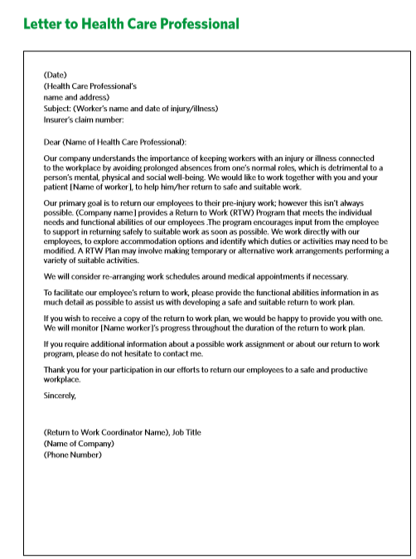
Doucment 7: Modified Work offer letter to injuried/ill person

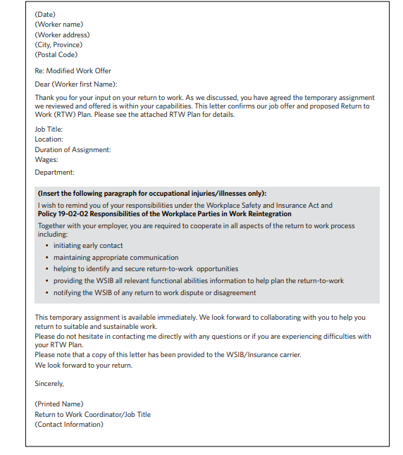

Doucment 8: Medical Consent for release of Information

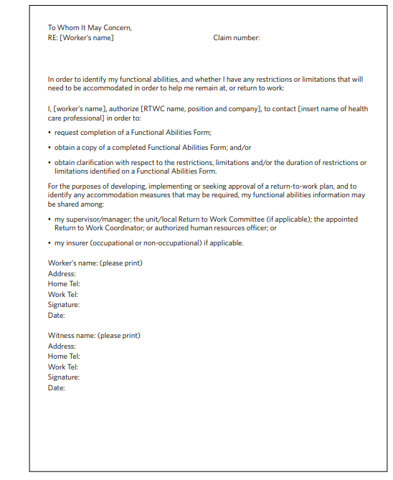

Doucment 9: Retunr-to-Work Plan Closure and Evalution feedback froms
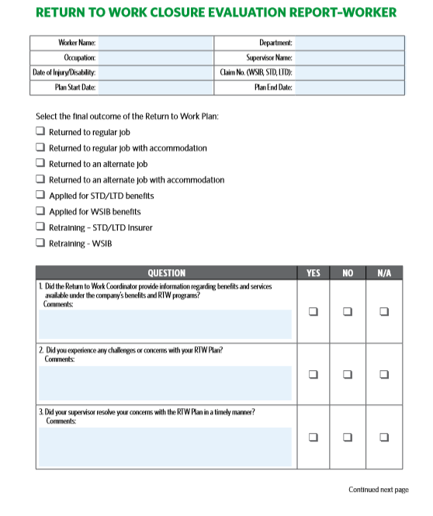
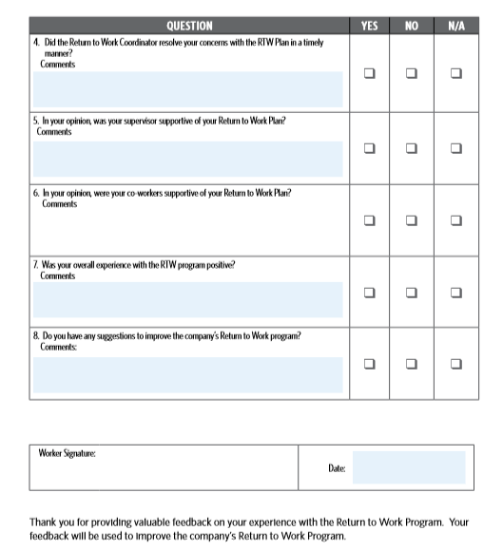

CHANGES TRACKING
DETAILS OF CHANGES | DATE CHANGED

